**COMMUNITY FORUM FEEDBACK REPORT**

The community activity was done at Kadenge Village area of Siaya County

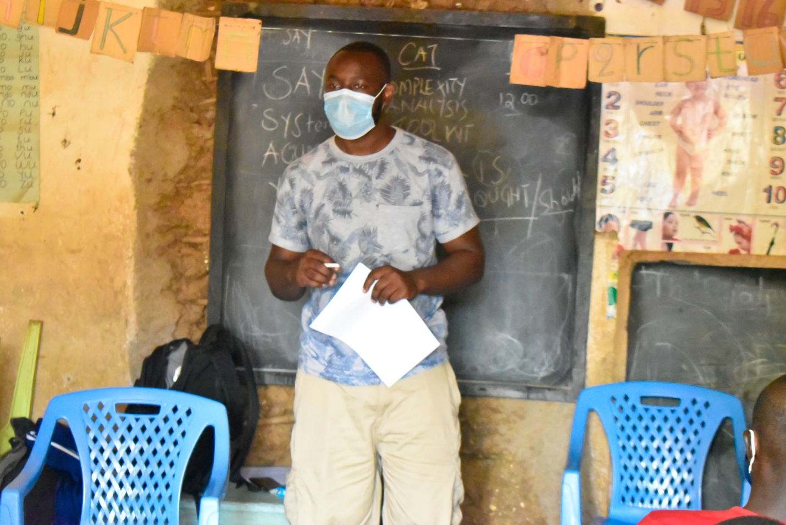

**CAT**

**Identifying the components of the system, their roles and interactions**

* School Administration/Teachers

Through teachers attitudes and values, they inspire, motivate, encourage and educate learners by imparting knowledge to them and by setting up a situation in which students can and will learn effectively and at the same time some have negative attitude towards other students and often provide under-quality education and perpetrators of GBV by having sexual relationships with their students.

* Parents

they provide basic school requirements such as school uniforms, pay school fees and offer parental care, involvement and a home environment. They also give direction, impose rules, use discipline, set limits, establish and follow through with consequences, hold their children accountable for their behavior, teach values and provide the guidance that helps children to change, grow, and mature. However, other parents are unable to provide basic school requirements, engage in physical and emotional GBV/child abuse and labour at home and others provide little to no involvement in school activities.

* Police

They maintain order and security in the community and provide a positive learning environment as they engage with students, teachers, staff, and the community to foster school-police partnership. Some police officers take bribes for night music in the villages, fail to provide security, collaborate with the business community in peddling drugs and alcohol being supplied to students.

* Chief/village Elder

Work hand in hand with the police to stop Night music in the community which have contributed to defilement cases and teenage pregnancies and STIs. Some chiefs are a stumbling block to caregivers accessing CDF bursary as they are corrupt.

* Health professionals

They provide immunization, care and treatment as some contribute to increased abortion cases and sexual education on family planning to young girls

* Politicians

They provide bursaries and support with great passion for political mileage. MPs and their staffs are abusive and always corrupt when it comes to CDF bursaries as some engage in sexual relationships with the applicants

* Learners

Peer influence on use of drugs and substances as others offer support to other students due to the community culture

* The business community

offer odd jobs to young boys and girls, selling drugs and alcohol to school going children

**Provide list of factors that they think create the(give a good reason) the problem**

* Negative Community culture, values and norms encourage school absconding, gender inequality in house chores for school going girls and boys
* Food poverty
* Inadequate if not lack of parental care and involvement in school matters, especially fathers or male caregivers accompanied by high levels of illiteracy on how to get involved
* Gender Based Violence and unstable home environment
* Individual learner attitude and perceptions towards education
* Inadequate and unsafe learning structures
* Corrupt officers in charge of CDF bursaries
* Poor ethical practices by the business community
* Peer pressure among learners
* High taxes on learning equipment and accessories by the government
* Drugs and substance abuse
* Negative teacher attitude and commitment in providing quality education to learners

Report Written by Tyrus Omondi and Caren Ogweyo

Date:

**Photo Gallery**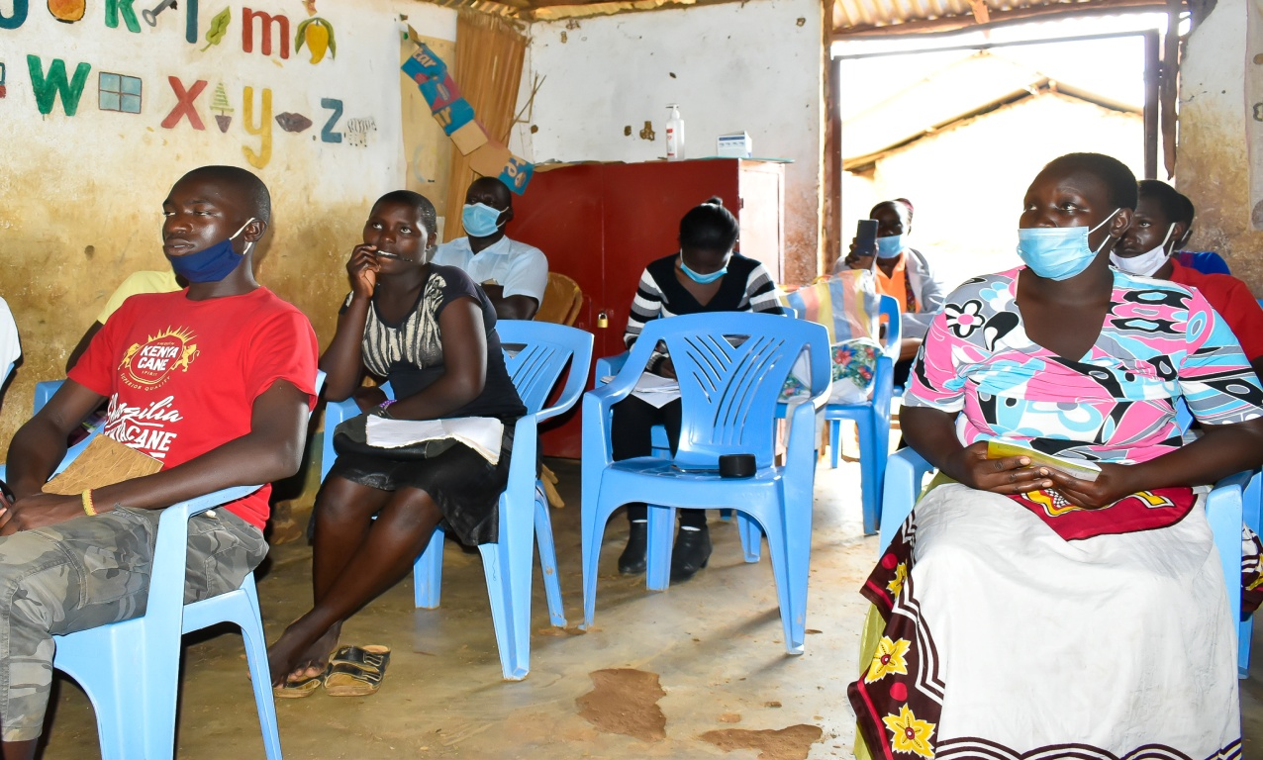

**Active participation noted**

